Promotional Kit for Demolition Phoenix
Thank you for exhibiting at Demolition Phoenix. The purpose of this toolkit is to provide you easy to use resources to help promote your participation at the upcoming Annual Convention and Expo. We appreciate your support and look forward to a great event in Phoenix! If you have any questions about the toolkit, please feel free to contact Taylor Collison via email at tcollison@demolitionassociation.com
- Web Content
- Social Media
- Sample Email
- Email Signature

Web Content
Web Banner
Add the following web banner to any appropriate high-profile page on your personal or company’s website/blog to promote the event. This banner is also usable with social media, email communications, etc. Additional sizes are available. When possible, link the web banner to the Demolition Phoenix homepage here: www.demolitionassociation.com/convention

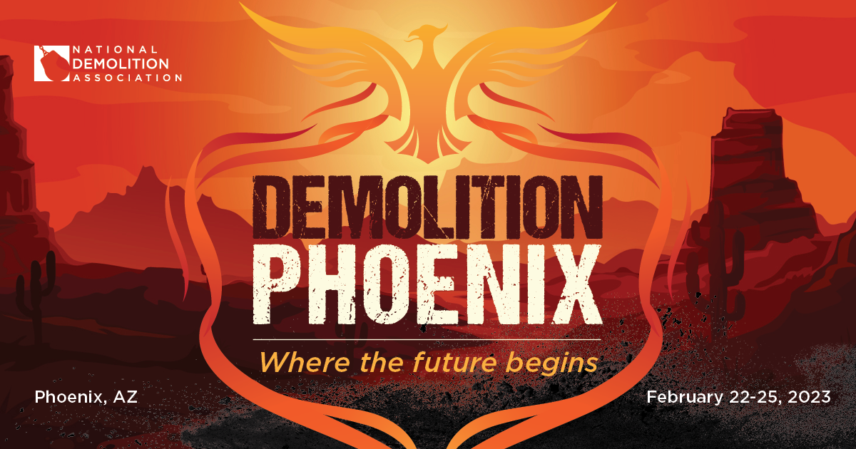
Web Copy
Use the copy below to promote the event on your website, tailoring depending on the page and area of your website. Can’t use all the copy below? Just use the abbreviated listing – event name, date, location, and URL.
Event Description: Join NDA and [Company Name] at Demolition Phoenix February 22-25, 2023. This year’s event will reconnect professionals as the industry gets back to work in earnest. Featuring the ever-popular Live DEMOlition Event, the fast and furious presentations, and education from industry leaders, the Annual Convention and Expo is more than just networking. Don’t miss [Company Name] in the Expo to access our range of products and service offerings that can help you add efficiencies, capture new opportunities and increase profits.
Visit the NDA website to learn more about Demolition Phoenix and register today!
Abbreviated Event Details:
Demolition Phoenix
February 22-25, 2023
Phoenix, AZ
www.demolitionassociation.com/convention

Social Media
The following social media posts are recommendations, but can be tailored to your voice and depending on the platform/account you are posting on. You can also draft your own! Consider using the web banner above as well.
Facebook / LinkedIn:
Join the National Demolition Association for Demolition Phoenix! Visit [Company name] at [booth #] in the Expo. Register today and we’ll see you there! www.demolitionassociation.com/Education-Events/Demolition-Phoenix-2023/Registration
[Company name] and other leading manufacturers will be in attendance at Demolition Phoenix – will you? Register to join us and the National Demolition Association in Phoenix February 22-25! www.demolitionassociation.com/Education-Events/Demolition-Phoenix-2023/Registration
[Company name] is exhibiting at Demolition Phoenix. Register and stop by the Expo at [booth #] to learn more about our latest products and services! www.demolitionassociation.com/Education-Events/Demolition-Phoenix-2023/Registration
Visit us at our booth in the Expo at Demolition Phoenix, your one-stop-shop for all things demolition. The National Demolition Association is connecting our industry so join us in Phoenix. Find the full schedule on the event website. www.demolitionassociation.com/Education-Events/Demolition-Phoenix-2023/Schedule
As 2023 approaches, it’s more important than ever to connect with each other and stay up-to-date on the latest products and services to help your company work more effectively, save more money, and keep employees safe. NDA’s Demolition Phoenix is the perfect place to gain that knowledge. [Company name] is exhibiting and featuring [products, services, etc.] – this is a can’t-miss event, so register today! www.demolitionassociation.com/Education-Events/Demolition-Phoenix-2023/Registration
What can you expect at Demolition Phoenix? Leading manufacturers and suppliers, including [Company name], will provide one-stop access to the latest technologies and tools to help your business. Register today and visit our booth in Phoenix! www.demolitionassociation.com/Education-Events/Demolition-Phoenix-2023/Registration
Facebook and LinkedIn Tips:
- In addition to sharing a post on your own Facebook timeline and LinkedIn profile, consider posting in a related group you belong to. Be sure to abide by group policy.
- Adding your own customization can go a long way towards ensuring that your post is read and not considered spam. Consider adding a personal message, including a related photo.
- Don’t forget to tag the NDA Facebook page or LinkedIn page!

Twitter:
Register for #DemolitionPhoenix as @NDAMakingWay reconnects the industry, February 22-25. And stop by [booth #] in the Expo to learn more about our latest products. Learn more: https://bit.ly/3N5bgrX
Join [Company name] at #DemolitionPhoenix February 22-25! [Company name] will be exhibiting and featuring [products, services, etc.]. Learn more: https://bit.ly/3N5bgrX
Don’t miss out on @NDAMakingWay’s #DemolitionPhoenix – the industry is connecting industry leaders! [Company name] will be exhibiting and hope to see you there. Learn more: https://bit.ly/3N5bgrX
Why do I attend @NDAMakingWay’s annual convention? [ideas: the Live DEMOlition Event™, fast-and-furious education sessions, the industry-leading exhibitors, connecting with colleagues from across the country]. Register to join me at #DemolitionPhoenix February 22-25! https://bit.ly/3N5bgrX
What can you expect at #DemolitionPhoenix? Leading manufacturers and suppliers like [Company name] will provide one-stop access to the latest technologies and tools to help your business. Register to join us in Phoenix! https://bit.ly/3N5bgrX
At #DemolitionPhoenix, learn how to help your company work more effectively, save more money, and keep employees safe. [Company name] will be exhibiting our latest products and services that help you do just that. Register to join today! https://bit.ly/3N5bgrX
Twitter Tips:
- Tweets have a maximum length of 280 characters, including URLs, hashtags and punctuation. Be direct and succinct.
- Use URL shorteners whenever possible.
- Use the event hashtag: #DemolitionPhoenix in your Tweets.
- Add any relevant and active industry hashtags to (i.e. #demolition #demolitionindustryevents)
- Remember to diversify your posts. Spamming the same Tweet can generate a negative reaction from the community.
- Avoid posting at early or late hours of the day. During normal business hours is preferred and ideal.
- Follow and tag NDA’s Twitter account (@NDAMakingWay) for additional engagement opportunities.

Email
Below is a sample email you can use to reach out to professional contacts in the industry to help spread the word about Demolition Phoenix and invite them to attend. We recommend you tailor this to your own voice and personal style where applicable so that it does not feel like spam to your contact.
[Subject]: Join [me/company name] at Demolition Phoenix!
[Body]
Dear <name>,
I’m excited that [company name] will join the National Demolition Association at their Annual Convention and Expo early next year. Demolition Phoenix is taking place February 22-25 and I’d love to see you join us too. As you know, our industry is getting back to work in earnest and this gathering will give us the chance to reconnect and push forward together.
Event highlights include:
- The ever-popular Live DEMOlition Event™
- Educational content to help take your business to another level
- Leading exhibitors including [company name] in the Expo
- Hands-on, interactive learning with equipment
- Opportunities to develop and strengthen relationships with industry colleagues
I can’t recommend Demolition Phoenix enough, at a time when it’s needed most. Visit us in the Expo as we’re showcasing [insert products, services].
You can learn more about registration here and we hope to see you in Phoenix!
[Signature]
Email Signature
Consider adding the banner below to your email signature in order to increase awareness of your attendance at Demolition Phoenix with your professional contacts. You can use the template below or customize your current signature by adding the image/banner. Remember to link the image to www.demolitionassociation.com/convention

Name
Title | Company
Address 1, Address 2 | City, State Zip
P: +1.XXX.XXX.XXXX | E: email@email.com
